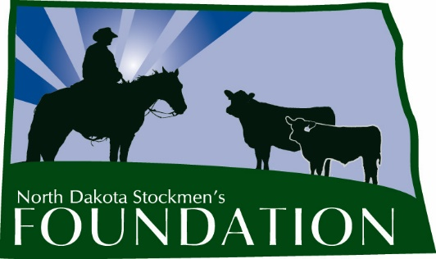

NORTH DAKOTA STOCKMEN’S FOUNDATION ENDOWMENT SCHOLARSHIP

NAME: The name of this scholarship is the North Dakota Stockmen’s Foundation Endowment Scholarship.

PURPOSE: The purpose of this scholarship is to provide a source of financial support for a student majoring in Animal Science, Range Science, Pre-Vet, Agribusiness, Ag Communications, Farm & Ranch Management, or another beef-related discipline at a North Dakota college or university.

INCLUDES: The scholarship will be for $500 and will include a one-year membership in the North Dakota Stockmen’s Association.

ELIGIBILITY: Students eligible for this scholarship will:
1. Be residents of North Dakota.
2. At the time of application, be a high school senior, a college freshman, sophomore or junior majoring or intending to major in one of the areas listed above.
3. Have an interest in the beef cattle industry of North Dakota.
4. Be a member or a child of a member of the North Dakota Stockmen’s Association.
5. Submit a completed application to the North Dakota Stockmen’s Foundation. Emailed applications will not be accepted.
6. Have a G.P.A. of 2.0 or greater.

MANNER AND TIME OF CHOICE:
The deadline to submit applications to the North Dakota Stockmen’s Association office is March 1 of each year. The scholarship committee will make the final selection. Payment will be made following enrollment in the fall semester.

FUNDING: Upon selection of the recipient, the North Dakota Stockmen’s Foundation will forward a check for the amount of the award to the college or university development foundation. The Foundation will make the scholarship payment upon authorization by the office of student financial aid.

GUIDELINES: 1. The Scholarship Selection Committee will be made up of the NDSF advisory committee chairman and at least three other livestock industry professionals.

2. Any changes deemed necessary must be made by the North Dakota Stockmen’s Foundation Board of Directors.

3. The winner will be published in the North Dakota Stockman and other publications and if possible, be recognized at the annual convention in order to give the winner and the North Dakota Stockmen’s Foundation as much positive publicity as possible.

4. The scholarship selection should include these criteria:
a. Need.
b. Application form.
c. Interest in the beef industry.

5. Application will include:
a. A description of the applicant’s involvement in the cattle industry (activities, organizations, awards, etc.)
b. Why the applicant chose his or her current major.
c. What the applicant sees for the future of the cattle industry.
d. What the applicant’s plans are involving the cattle industry following graduation.
ENDOWMENT SCHOLARSHIP

First Name: Middle Initial: Last Name:
Home Address:
Current Grade: School Address:
Home Phone: Cell Phone: School Phone:
Parent's Name & Address:
Birthdate: High School GPA: College GPA:
Major/Minor:
Reason for applying for scholarship:
Other scholarships you have received and the dollar amounts of the scholarships:
Why did you choose your current major?
What are your plans involving the cattle industry following graduation?
Describe your involvement in the cattle industry (activities, organizations, awards, etc.):
Describe your involvement in your school and community (activities, organizations, awards, etc.)
ON A SEPARATE SHEET: Discuss an issue that is important to North Dakota cattle producers.
Provide two letters of reference and transcript (must be included with application).
Signature:

Completed application should be submitted by March 1 to:

North Dakota Stockmen's Foundation Endowment Scholarship
c/o North Dakota Stockmen's Association
407 S. 2nd Street
Bismarck, ND 58504

