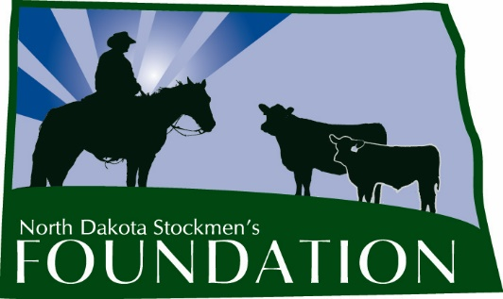

NORTH DAKOTA STOCKMEN’S FOUNDATION

JACK & VANDER REICH MEMORIAL ENDOWMENT SCHOLARSHIP

NAME: The name of this scholarship is the North Dakota Stockmen’s Foundation Jack and Vander Reich Memorial Endowment Scholarship.

PURPOSE: The purpose of this scholarship is to provide a source of financial support for a student preparing to study an agricultural major and to honor the memory of the late Jack and Vander Reich of Zap, who left a positive mark on the North Dakota beef industry. Jack Reich was a well-known Angus breeder and a respected industry leader, who served as the president of the North Dakota Stockmen’s Association and a director of the National Cattlemen’s Beef Association and the North Dakota Angus Association. Ten-year-old Vander Reich was an active fifth grader who loved to hunt, fish, cowboy and spend time with his family. The pair died in an automobile accident in November 2012.

INCLUDES: The scholarship will be for $750.

ELIGIBILITY: Students eligible for this scholarship will:
1. At the time of application, be a high school senior.
2. Have an interest in the beef cattle industry of North Dakota.
3. Be a member or a child of a member of the North Dakota Stockmen’s Association.
4. Be planning to major in an agriculturally related discipline at any accredited college or university.
5. Submit a completed application to the North Dakota Stockmen’s Foundation. E-mailed applications will not be accepted.

PREFERENCE: Although not a requirement, preference may be given to applicants with an interest in rodeo and/or shooting sports.

MANNER AND TIME OF CHOICE:
The deadline to submit applications is March 1. Payment will be made following enrollment in the fall semester of college, in approximately October of the award year.

FUNDING: Upon selection of the recipient, the North Dakota Stockmen’s Foundation will forward a check for the amount of the award to the college or university development foundation. The Foundation will make the scholarship payment upon authorization by the office of student financial aid.

GUIDELINES: 1. The Scholarship Selection Committee will be made up of the North Dakota Stockmen’s Foundation president, at least three other livestock industry professionals and a member of the Reich family or their designee.

2. The winner will be announced in the North Dakota Stockman and other publications and be recognized at the annual convention.

3. Application will include:
a. The applicant’s background.
b. Why the applicant chose his or her current major.
c. The applicant’s future plans.
d. The applicant’s school and community activities.
e. The applicant’s work experience.
f. A short essay.
g. Two letters of reference and a transcript (must be included with application)

JACK AND VANDER REICH MEMORIAL ENDOWMENT SCHOLARSHIP
First Name: Middle Initial: Last Name:
Home Address:
Home Phone: Cell Phone: School Phone:
Parent’s Name & Address:
Birthdate: Current Grade: High School GPA:
College/University applicant will be attending:
Major/Minor:
Describe your background:
Why did you choose your current major?
What are your plans for the future?
Describe your involvement in your school and community (activities, organizations, awards, etc.):
Describe any work experience you have that will help prepare you for your career in agriculture:
ON A SEPARATE SHEET: Write an essay of no more than 750 words describing how you will contribute to a bright future for agriculture.
Provide two letters of reference and a transcript (must be included with application).
Signature:

Completed application should be submitted by March 1 to:

North Dakota Stockmen’s Foundation
4520 Ottawa St.
Bismarck, ND 58503

