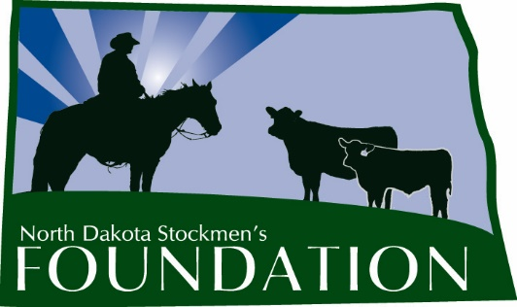

NORTH DAKOTA STOCKMEN’S FOUNDATION

TOKACH ANGUS RANCH MEMORIAL SCHOLARSHIP

NAME: The name of this scholarship is the North Dakota Stockmen’s Foundation Tokach Angus Ranch Memorial Scholarship.

PURPOSE: The purpose of this scholarship is to provide a source of financial support for a student majoring in animal science, range science, pre-vet, agribusiness, ag communications, farm and ranch management or another beef-related discipline.

INCLUDES: The scholarship will be for $1,000 and includes a one-year membership in the North Dakota Stockmen’s Association.

ELIGIBILITY: Students eligible for this scholarship will:
1. Be residents of North Dakota.
2. Have a grade point average of at least 3.0.
3. At the time of application, be enrolled in an institution of higher education in a discipline listed above.
4. Have an interest in the state’s beef cattle industry.
5. Be a member or a child of a member of the North Dakota Stockmen’s Association.
6. Submit the required application form, essay, transcript and references. E-mailed applications will not be accepted.

The scholarship is based primarily on need and a desire for higher education, with scholastic achievement, leadership, extra-curricular activities and moral character being secondary concerns. Preference will be given to students who have completed their bachelor’s degree and who are pursuing a graduate education or professional school (i.e. veterinary or law school).

MANNER AND TIME OF CHOICE:

The deadline to submit applications is March 1. The scholarship committee will make the final selection. Payment will be made following enrollment in the fall semester, approximately in October of the award year.

FUNDING: Upon selection of the recipient, the North Dakota Stockmen’s Foundation will forward a check for the amount of the award to the college or university development foundation. The Foundation will make the scholarship payment upon authorization by the office of student financial aid.

GUIDELINES: 1. The Scholarship Selection Committee will be made up of the North Dakota Stockmen’s Foundation president and at least three other livestock industry professionals.

2. The winner will be published in the North Dakota Stockman and other publications and be recognized at the annual convention.

3. The scholarship selection should include these criteria:
a. Need.
b. Application form, transcript, essay and two references.
c. Interest in the beef industry.

4. Application will include:
a. A description of the applicant’s involvement in the cattle industry (activities, organizations, awards, etc.)
b. Why the applicant chose his or her current major.
c. What the applicant sees for the future of the cattle industry.
d. What the applicant’s plans are involving the cattle industry following graduation.

TOKACH ANGUS RANCH MEMORIAL SCHOLARSHIP
First Name: Click or tap here to enter text. Middle Initial: Click or tap here to enter text. Last Name: Click or tap here to enter text.
Home Address: Click or tap here to enter text.
Current Grade: Click or tap here to enter text. School Address: Click or tap here to enter text.
Home Phone: Click or tap here to enter text. Cell Phone: Click or tap here to enter text. School Phone: Click or tap here to enter text.
Parent’s Name & Address: Click or tap here to enter text.
Birthdate: Click or tap here to enter text. High School GPA: Click or tap here to enter text. College GPA: Click or tap here to enter text.
Major/Minor: Click or tap here to enter text.
Reason for applying for scholarship: Click or tap here to enter text.
Other scholarships you have received and the dollar amounts of the scholarships: Click or tap here to enter text.
Why did you choose your current major? Click or tap here to enter text.
What are your plans involving the cattle industry following graduation? Click or tap here to enter text.
Describe your involvement in the cattle industry (activities, organizations, awards, etc.): Click or tap here to enter text.
ON A SEPARATE SHEET: Discuss an issue that is important to North Dakota cattle producers.
Provide two letters of reference and a transcript (must be included with application).
Signature:

Completed application should be submitted by March 1 to:

North Dakota Stockmen’s Foundation
4520 Ottawa St.
Bismarck, ND 58503

